Excellent innovation work: PreciPoint receives Top100 seal of approval

Freising / Wildenspring – In terms of corporate management and innovation, PreciPoint is at the top. PreciPoint was recognized in the TOP 100 competition as a think tank and was awarded the TOP 100 seal 2022. Only particularly innovative medium-sized companies are awarded this distinction. PreciPoint entered the innovation competition TOP 100 2022 for the first time and was able to make a mark right from the start. A total of 436 medium-sized companies applied.
PreciPoint specializes in digitization solutions in the field of microscopy. The German company has two locations in Freising, Bavaria, and another in Großbreitenbach, Thuringia. PreciPoint has a wealth of experience in microscope manufacturing and its equipment is present in many laboratories worldwide. PreciPoint entered the Top100 innovation competition for the first time in 2022 and was able to convince the jury right from the start. A total of 436 medium-sized companies had applied.
"We won this award because we have a great team working together to make surgical and clinical cancer diagnostics more effective and efficient," says Dominik Gerber, CEO of PreciPoint. Together with Nicolas Weiss, he leads the company, which has been headquartered in Freising, Germany, since 2013. "Our contribution is the digitalization of microscopy and laboratory workflows. Because where you live shouldn't determine whether you live," Weiss says. Pathology is currently in a transition phase toward digitization, "But it's not enough to buy equipment that digitizes samples. To make pathology fit for the future, all stakeholders must be involved in the process and new technologies must be established in the work processes." At the moment, PreciPoint is developing its first medical device, which is expected to receive approval this year: the iO:M8 - ROSE. The microscope can be used specifically for intraoperative consultations. It enables easy and fast collaborative work among medical professionals and facilitates obtaining a second opinion.
To receive a Top100 seal, a company must undergo a scientific selection process. On behalf of compamedia, the organizer of the comparison, the innovation researcher Prof. Dr. Nikolaus Franke and his team examined PreciPoint in more than 100 innovation indicators from five categories: Top Management Promoting Innovation, Innovation Climate, Innovative Processes and Organization, External Orientation/Open Innovation and Innovation Success. In principle, the TOP 100 analysis is concerned with the question of whether a company's innovations are just a product of chance or are systematically planned and thus repeatable in the future. Special weightage is given to the question of whether and how innovations and product improvements succeed in the market.

PreciPoint:
PreciPoint Group GmbH specializes in the development, production, and marketing of innovative digitization solutions and photonics systems in the field of microscopy. Already available on the market are its M8 microscope and scanner, O8 oil digital microscope and scanner, as well as FRITZ. All devices are fully motorized transmitted light microscopes, which work completely digitally, do not require an eyepiece, and produce high-resolution images of the samples, which can be stored digitally. The microscopes work with simple and intuitive user guidance via touch screen or mouse click and are controlled by software. In addition, the devices are equipped with a remote function so that they can also be accessed from any location. In addition to hardware products, the company also offers versatile software applications with which the images can be visualized, processed, and analyzed. The PreciCloud platform enables new working models and fast, low-data-intensive exchange between experts.

TOP 100: The competition
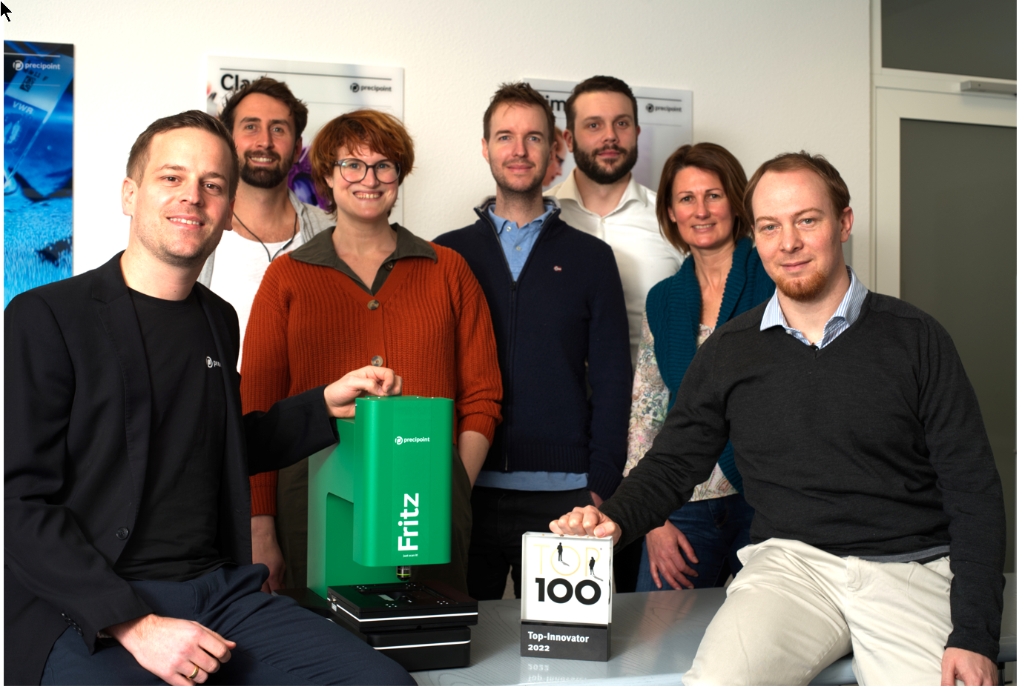
Since 1993, compamedia has been awarding the TOP 100 seal for special innovative strength and above-average innovation success to medium-sized companies. Scientific management has been in the hands of Prof. Dr. Nikolaus Franke since 2002. Franke is the founder and director of the Institute for Entrepreneurship and Innovation at the Vienna University of Economics and Business. With 25 research awards and over 200 publications, he is one of the leading innovation researchers internationally. The mentor of TOP 100 is science journalist Ranga Yogeshwar. Project partners are the Fraunhofer Society for the Promotion of Applied Research and the BVMW association of small and medium-sized enterprises. The magazines manager magazin and impulse accompany the company comparison as media partners. More information and registration at www.top100.de.
Representing all employees, Dominik Gerber, Michael Sysoev, Katharina Eser, Christian Nauck, Moritz Diez, Anne-France Carter, and Nicolas Weiss are pleased with the Top100 award (from left).

